CN LAB ASSIGNMENT 2  
  
BUS TOPOLOGY  
  
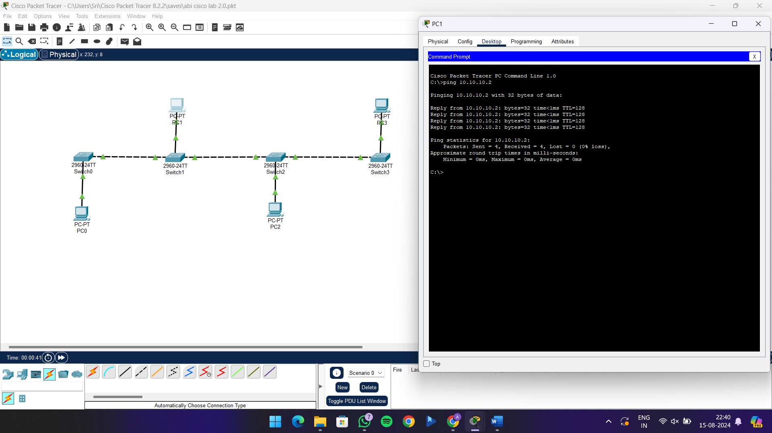

STAR TOPOLOGY  
  
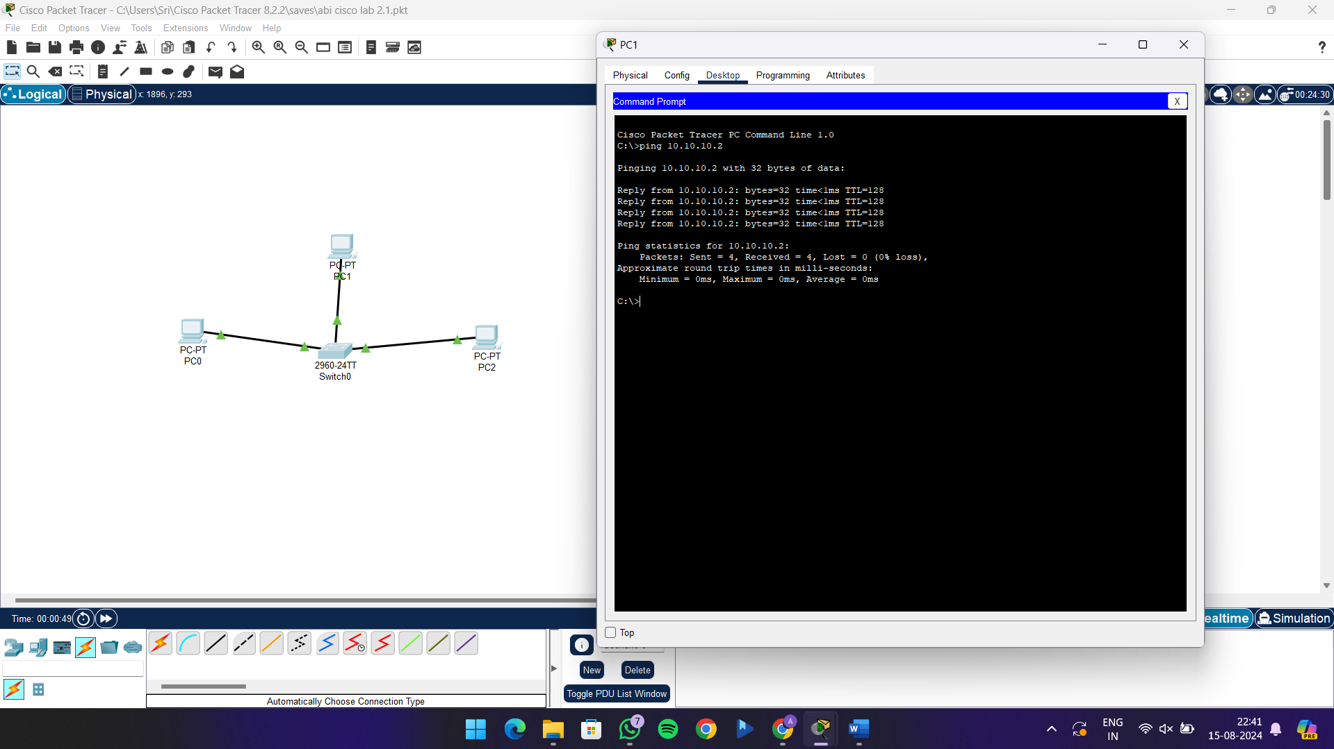

RING TOPOLOGY  
  
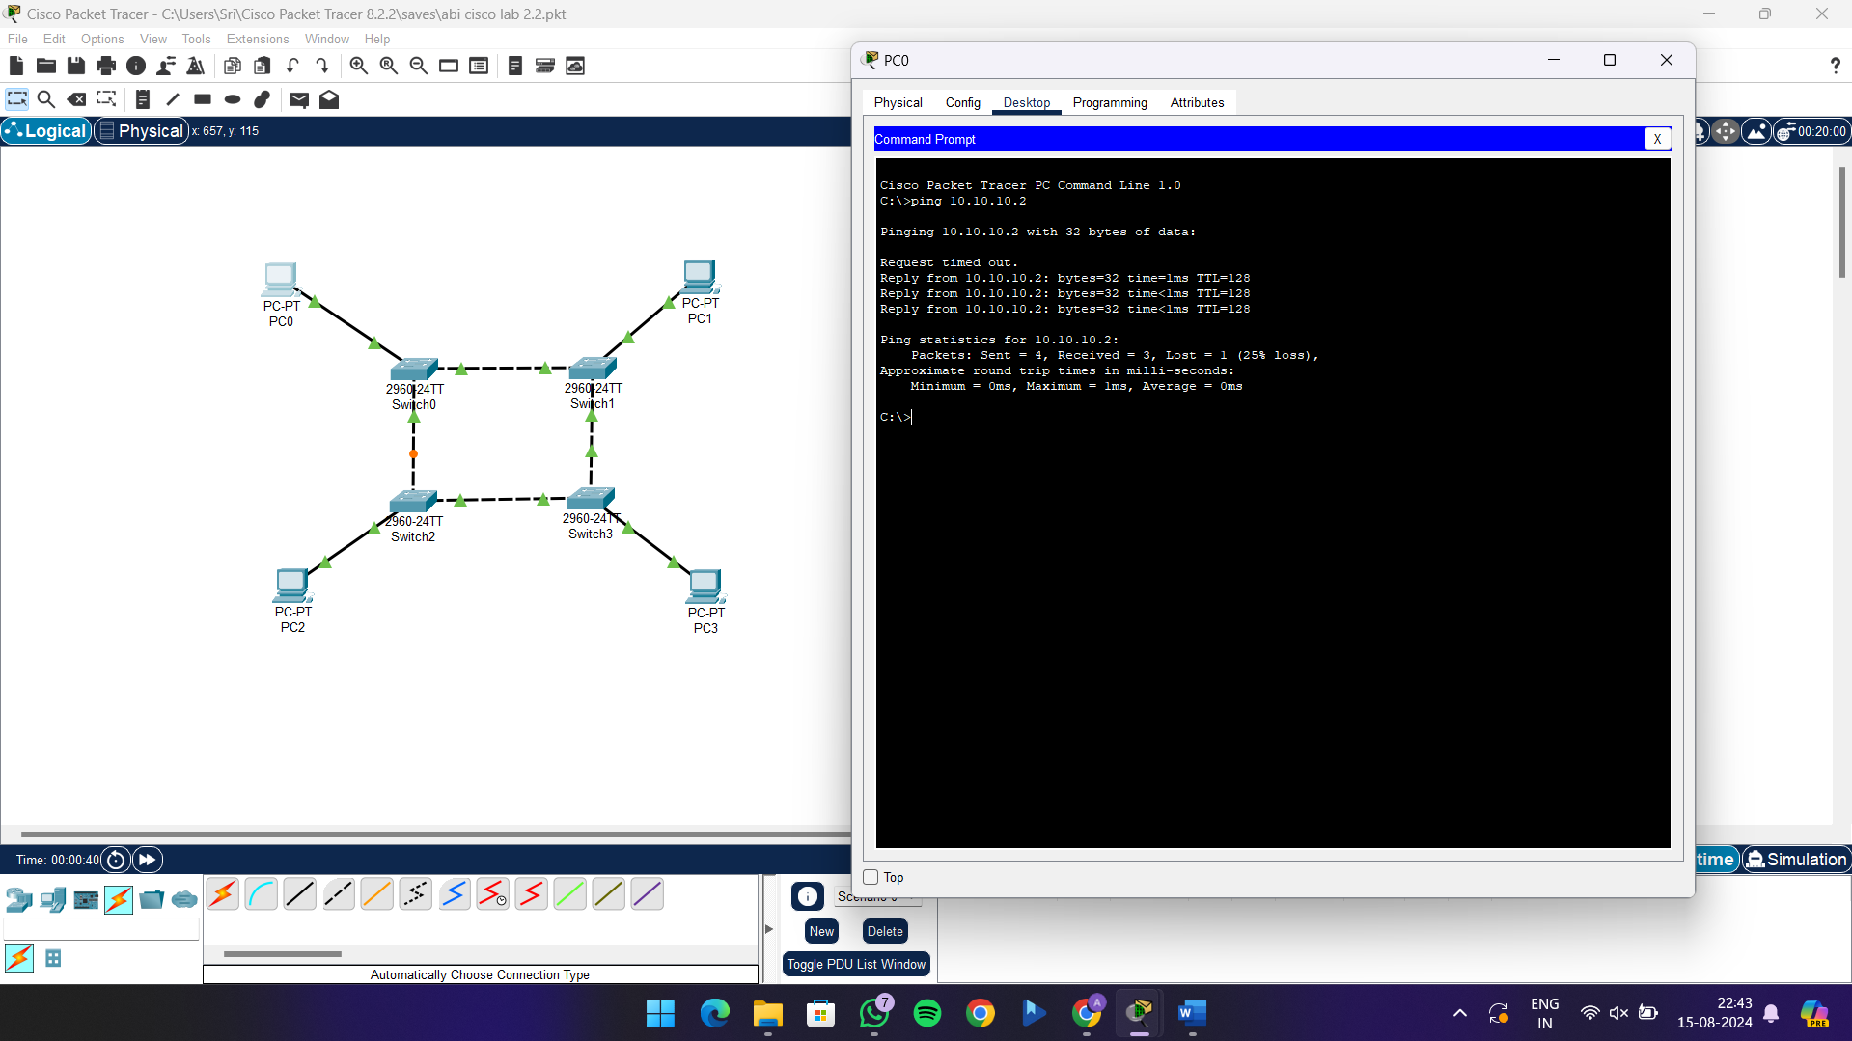  
  
MESH TOPOLOGY  
  
